AIRLINE USE CASE

1. INTRODUCTION
The airline industry produces a large amount of data through its day-to-day operations, including flight schedules, passenger information, bookings, and payment transactions. When this data is stored in different formats or contains missing and inconsistent values, it becomes difficult to use directly for analysis and reporting. Therefore, proper data preparation and organization are important before meaningful business insights can be obtained.
This project focuses on developing an end-to-end data engineering and business intelligence solution using an airline dataset. The provided dataset contains information related to flights, passengers, bookings, and payments. The project begins with the extraction of data from an Excel workbook, followed by data cleaning, validation, transformation, and quality assessment. The processed data is then stored in a structured SQLite database and organized into fact and dimension tables for analytical purposes.
Python and Pandas are used for data preprocessing and quality checks, while SQL is used to structure and analyze the processed data. Several analytical datasets are also generated to study booking trends, airline performance, route performance, booking status, payment information, and overall data quality. The final analytical results are intended to be presented through Power BI dashboards, providing an easy way to understand the important patterns in the airline data.
The project also gives importance to data quality and privacy. Issues such as missing values, duplicate records, invalid values, inconsistent flight information, and payment data quality are identified during the processing stage. Personally identifiable information such as passport numbers, Aadhaar IDs, contact details, and passenger names is not required for the business dashboards and is therefore excluded from the analytical presentation.

1.1 Project Objectives
The main objectives of this project are:
- To extract airline-related data from the provided Excel workbook.
- To examine the dataset and identify missing, duplicate, invalid, and inconsistent records.
- To clean and validate the data using Python and Pandas.
- To create a reproducible data processing pipeline for transforming the raw airline data into analysis-ready datasets.
- To store the cleaned data in a structured SQLite database.
- To develop a dimensional data model consisting of fact and dimension tables for analytical processing.
- To use SQL queries to calculate important metrics related to flights, bookings, routes, airlines, and payments.
- To analyze booking patterns, cancellation rates, airline performance, route performance, and payment information.
- To identify and report data-quality issues present in the original dataset.
- To develop Power BI dashboards that present the analytical results in an understandable and interactive manner.
- To ensure that sensitive passenger information is not unnecessarily exposed during analysis and visualization.
2. DATASET DESCRIPTION
The dataset used in this project is an airline operational dataset provided in the form of an Excel workbook. It contains information related to flights, passenger details, bookings, and payment transactions. The dataset is divided into four sheets, with each sheet representing a different area of the airline business.
The four sheets available in the original dataset are Flights, Bookings, Passengers, and Payments. These datasets are connected through common identifiers such as flight_id, passenger_id, and booking_id. These relationships allow the information from different tables to be combined for analysis.
2.1 Dataset Structure
Dataset | Number of Records | Main Purpose
Flights | 1,020 | Contains flight and route information
Bookings | 1,000 | Contains passenger booking and booking-status information
Passengers | 1,039 | Contains passenger demographic and contact information
Payments | 1,000 | Contains payment transaction information
The Flights sheet contains details such as airline, source airport, destination airport, departure time, arrival time, and flight duration. The Bookings sheet contains booking identifiers, passenger and flight references, booking dates, booking status, and seat information. The Passengers sheet contains demographic details such as age and gender along with personal contact information. The Payments sheet contains payment identifiers, booking references, payment amounts, and payment methods.

2.2 Dataset Attributes
Flights
The Flights dataset contains the following attributes:
- flight_id – identifies a particular flight.
- airline – represents the airline operating the flight.
- source – indicates the departure airport.
- destination – indicates the arrival airport.
- departure_time – records the scheduled departure date and time.
- arrival_time – records the scheduled arrival date and time.
- duration – represents the scheduled flight duration.
Bookings
The Bookings dataset contains:
- booking_id – unique identifier for a booking.
- passenger_id – links the booking to a passenger.
- flight_id – links the booking to a flight.
- booking_date – records when the booking was made.
- status – indicates whether the booking is confirmed, cancelled, or pending.
- passport_number – passenger passport information.
- seat_number – assigned seat information.
- emergency_contact_name – emergency contact details.
- emergency_contact_phone – emergency contact phone number.
Passengers
The Passengers dataset contains:
- passenger_id – unique passenger identifier.
- first_name and last_name – passenger name.
- age – passenger age.
- gender – passenger gender.
- email – passenger email address.
- phone – passenger contact number.
- aadhaar_id – passenger identification information.
- date_of_birth – passenger date of birth.
Payments
The Payments dataset contains:
- payment_id – unique payment identifier.
- booking_id – links the payment to a booking.
- amount – payment amount.
- payment_method – method used for the payment, such as UPI, CARD, or NETBANKING.

2.3 Dataset Relationships
The datasets are connected using their key identifiers. A booking is associated with a passenger through passenger_id and with a flight through flight_id. Payment transactions are connected to bookings using booking_id.
The overall relationship can be represented as:
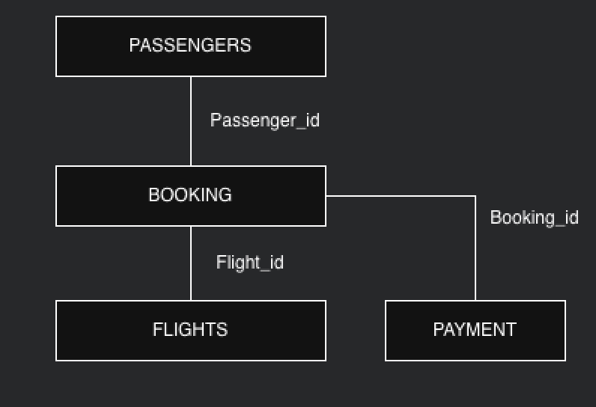
The airline datasets are related through common identifiers that allow information from different sources to be combined. The passenger_id field connects passengers with their bookings, while flight_id connects bookings with the corresponding flights. The booking_id field connects booking records with their associated payment transactions. These relationships provide the foundation for integrating the datasets and performing combined analysis.
These relationships form the basis for combining the datasets during analysis and for developing the dimensional data model used in the project.

3. DATA PREPROCESSING AND DATA QUALITY
The raw airline dataset was first examined to understand its structure and identify possible data quality issues. The preprocessing stage was performed using Python and Pandas before loading the data into the SQLite database. The main focus was to remove exact duplicate records, handle missing and invalid values, validate identifiers, and check the consistency of flight timings and payment information.

3.1 Data Cleaning
The following preprocessing activities were performed:
- Exact duplicate records were identified and removed from the Flights dataset. 15 duplicate records were removed, reducing the dataset from 1,020 to 1,005 records.
- Missing airline values and values recorded as UNKNOWN were standardized as Unknown.
- The flight_id format was validated. The dataset contained flight identifiers with prefixes such as AI, SJ, UK, and 6F, which were validated using an appropriate identifier pattern.
- Duplicate flight identifiers were checked. Two records with the flight ID 6F250 were identified and retained because their other flight details were different.
- Flight departure and arrival timestamps were checked for consistency.
- Overnight flights were identified by comparing the departure and arrival dates.
- One flight record was identified with an inconsistent timestamp and duration and was marked as an anomaly rather than being arbitrarily modified.
- Booking status values were standardized, with missing and invalid values represented as Unknown.
- Payment amounts were converted into numeric values. Invalid payment amounts were retained as missing rather than replacing them with assumed values.
- Passenger last-name missing values were standardized as Unknown.

3.2 Data Quality Results
The preprocessing stage resulted in the following important observations:
Data Quality Check | Result
Original flight records | 1,020
Duplicate flight records removed | 15
Cleaned flight records | 1,005
Duplicate flight IDs | 2 records
Overnight flights | 122
Flight anomalies | 1
Valid payment records | 922
Missing/invalid payment records | 78
Missing/invalid booking statuses | 75
The cleaning process was designed to preserve the original information wherever possible. Instead of deleting records unnecessarily, quality indicators such as time_quality, duration_mismatch, overall_quality, status_quality, and amount_quality were added to identify records requiring attention. This approach allows the cleaned dataset to be used for analysis while still retaining information about the quality of the original data.

3.3 Data Privacy
The dataset contains personally identifiable information, including passenger names, phone numbers, email addresses, Aadhaar identifiers, passport numbers, and emergency contact details. These attributes were not required for the business analysis and were therefore excluded from the Power BI reporting layer. This helps prevent unnecessary exposure of sensitive passenger information while allowing operational and financial information to be analyzed.

4. DATA ENGINEERING PIPELINE
The data engineering pipeline was developed to transform the raw airline dataset into structured and analysis-ready data. The pipeline follows a sequence of extraction, cleaning, validation, transformation, storage, and analysis stages. This approach ensures that the same processing steps can be repeated whenever the source dataset needs to be processed again.

4.1 Pipeline Workflow
The overall workflow used in the project is:
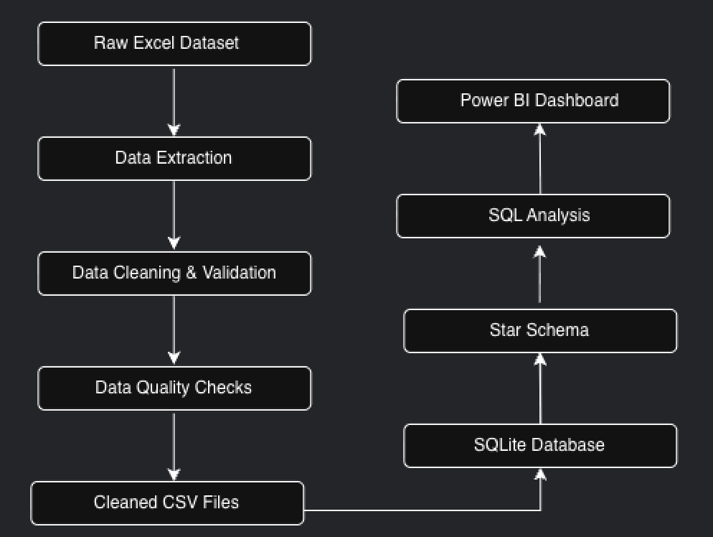

4.2 Data Extraction
The original airline dataset was provided as an Excel workbook containing four sheets: Flights, Bookings, Passengers, and Payments. Python and Pandas were used to read the sheets and convert them into DataFrames for further processing.
Each dataset was processed separately so that data-quality problems could be identified according to the type of information it contained.

4.3 Data Transformation
During the transformation stage, missing and invalid values were handled according to their meaning rather than being replaced arbitrarily. Duplicate flight records were removed, airline values were standardized, booking statuses were validated, and payment amounts were converted into numeric values.
Additional fields were created to support analysis and data-quality monitoring. These included overnight flight indicators, timestamp quality, duration mismatch indicators, overall flight quality, booking status quality, and payment amount quality.

4.4 Data Storage
After preprocessing, the cleaned datasets were stored in a SQLite database named airlines.db. The database contains the main tables required for further analysis.
The final database contains:
- flights
- bookings
- passengers
- payments
A dimensional structure was then created from these tables to make the data more suitable for analytical queries and business intelligence reporting.

4.5 Analytical Outputs
SQL was used to generate analytical datasets from the processed data. These outputs include:
- Booking trends
- Airline performance
- Route performance
- Booking status distribution
- Data-quality summary
These datasets provide the required information for the final Power BI dashboards.

4.6 Reproducibility
A Python pipeline script was developed to automate the major data-processing steps. Instead of manually repeating the cleaning and database creation process, the pipeline performs the required transformations in a consistent sequence. This improves reproducibility and reduces the possibility of differences caused by manual processing.
4.7 Technology Stack
Component | Technology Used
Source Data | Microsoft Excel
Data Processing | Python
Data Manipulation | Pandas
Database | SQLite
Database Connectivity | SQLAlchemy
Data Analysis | SQL
Visualization | Power BI
Documentation | Microsoft Word / Excel

5. DATABASE DESIGN AND STAR SCHEMA
After the data cleaning and transformation process, the processed airline data was stored in a SQLite database. To make the data easier to analyze, a dimensional model was created using fact and dimension tables. The star schema separates descriptive information from transactional information and provides a structured foundation for business intelligence analysis.

5.1 Star Schema Structure
The project uses two dimension tables and two fact tables:
- dim_passenger – contains passenger-related attributes required for analysis.
- dim_flight – contains flight, airline, route, timing, and quality-related information.
- fact_booking – contains booking transactions and booking status information.
- fact_payment – contains payment transactions and payment-related information.
The relationship between these tables can be represented as:
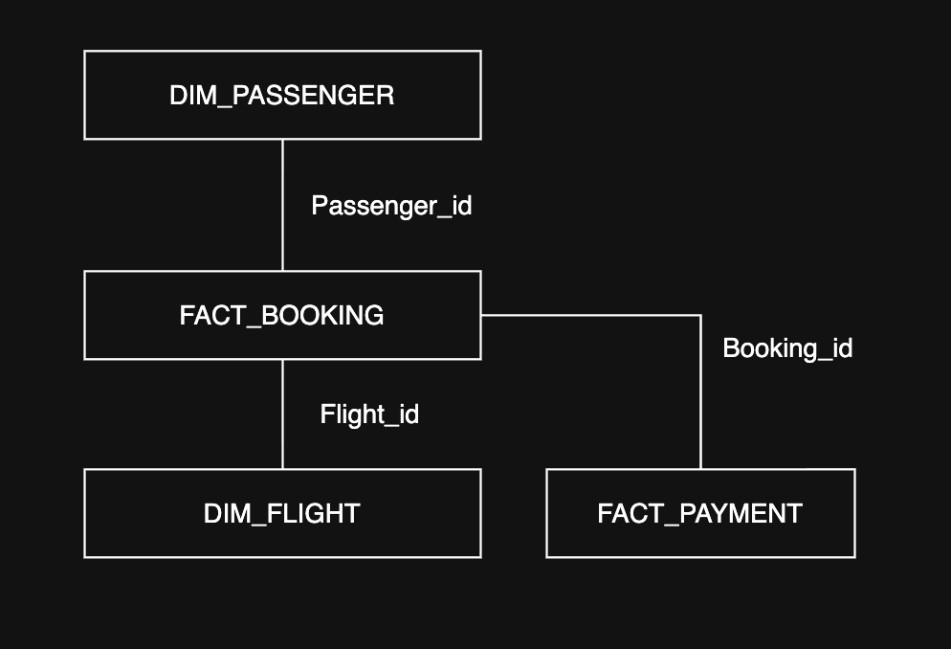

5.2 Dimension Tables

dim_passenger
The dim_passenger table stores the passenger attributes required for analytical purposes. Sensitive personal information is not included in this table.
Column | Description
passenger_id | Unique passenger identifier
age | Age of the passenger
gender | Gender of the passenger
The table contains 1,039 passenger records.

dim_flight
The dim_flight table contains information about flights, including airline, route, timing, duration, and data-quality indicators.
Column | Description
flight_id | Flight identifier
airline | Airline operating the flight
source | Departure airport
destination | Arrival airport
departure_time | Departure date and time
arrival_time | Arrival date and time
duration | Flight duration
overnight | Overnight flight indicator
time_quality | Timestamp quality status
duration_mismatch | Duration mismatch indicator
overall_quality | Overall flight quality
flight_id_valid | Flight ID validation status
duplicate_flight_id | Duplicate flight ID indicator
The table contains 1,005 flight records.

5.3 Fact Tables

fact_booking
The fact_booking table represents booking transactions. It contains references to passengers and flights along with the booking date and booking status.
The table contains 1,000 booking records.

fact_payment
The fact_payment table represents payment transactions associated with bookings. It contains payment amounts, payment methods, and payment-quality information.
The table contains 1,000 payment records.

5.4 Purpose of the Star Schema
The star schema provides a clear structure for analyzing the airline data from different perspectives. For example, booking information can be analyzed by passenger characteristics, while flight performance can be studied by airline and route. Payment information can also be connected to bookings to examine revenue and payment methods.
This structure also makes it easier to connect the processed database with Power BI and create analytical dashboards without unnecessarily exposing sensitive passenger information.

5.5 Final Database Tables
Table | Type | Records
dim_passenger | Dimension | 1,039
dim_flight | Dimension | 1,005
fact_booking | Fact | 1,000
fact_payment | Fact | 1,000

6. SQL ANALYSIS AND KEY PERFORMANCE INDICATORS (KPIs)
After creating the database and star schema, SQL queries were used to analyze the processed airline data. The analysis focuses on flight operations, booking activity, routes, payments, and data quality. These queries provide measurable indicators that can later be represented through Power BI dashboards.

6.1 Flight Analysis
The cleaned Flights dataset contains 1,005 flight records. Out of these, 1,004 records were classified as valid, while 1 record was identified as an anomaly. The analysis also identified 122 overnight flights.
The flight analysis helps evaluate the distribution of flights across airlines and routes while also identifying records that require further attention.

6.2 Booking Analysis
A total of 1,000 bookings are available in the dataset.
Booking Status | Number of Bookings | Percentage
Confirmed | 320 | 32.0%
Cancelled | 314 | 31.4%
Pending | 291 | 29.1%
Unknown | 75 | 7.5%
Total | 1,000 | 100%
The cancellation rate is 31.4%, calculated using the number of cancelled bookings relative to the total number of bookings.

6.3 Airline Performance
The distribution of valid flight records across airlines is:
Airline | Flights
IndiGo | 249
SpiceJet | 236
Air India | 233
Vistara | 218
Unknown | 69
IndiGo has the highest number of flight records in the dataset, while 69 records have an unknown airline value after data cleaning.

6.4 Route Analysis
The ten most frequently occurring routes are:
Rank | Route | Flights
1 | BOM → CCU | 90
2 | CCU → DEL | 72
3 | MAA → BLR | 65
4 | BLR → BOM | 60
5 | HYD → MAA | 57
6 | DEL → HYD | 54
7 | HYD → DEL | 42
8 | BOM → DEL | 39
9 | CCU → BOM | 33
10 | DEL → BLR | 29
This analysis helps identify routes with relatively higher flight activity in the available dataset.

6.5 Flight Duration Analysis
The average duration of valid flights is approximately 164.49 minutes, which is around 2 hours and 44 minutes.
The average duration by airline is:
Airline | Average Duration
IndiGo | 167.70 minutes
Unknown | 166.07 minutes
SpiceJet | 163.61 minutes
Air India | 163.15 minutes
Vistara | 162.68 minutes
The differences between airlines are relatively small, indicating that the average flight duration is broadly similar across the airlines represented in the dataset.

6.6 Payment Analysis
The dataset contains 1,000 payment records. Of these, 922 payments contain valid amounts, while 78 records contain missing or invalid payment amounts.
The total revenue calculated using only valid payment amounts is approximately:
₹73,85,142.98
The average valid payment amount is ₹8,009.92.
Metric | Value
Total Payments | 1,000
Valid Payments | 922
Invalid/Missing Payments | 78
Total Revenue | ₹73,85,142.98
Average Payment | ₹8,009.92
Minimum Payment | ₹1,002.59
Maximum Payment | ₹14,992.95

6.7 Payment Method Analysis
Payment Method | Transactions | Revenue
UPI | 358 | ₹26,18,686.77
CARD | 329 | ₹24,00,812.04
NETBANKING | 313 | ₹23,65,644.17
UPI has the highest number of payment transactions and also contributes the highest total revenue among the three payment methods.

6.8 Data Quality Analysis
The SQL analysis also provides a summary of data quality across the major datasets. Quality flags created during preprocessing allow valid and problematic records to be identified without deleting potentially useful information.
The main quality issues identified include:
- Duplicate flight records
- Duplicate flight identifiers
- Missing or unknown airline values
- Invalid flight timing information
- Flight duration mismatch
- Missing or invalid booking statuses
- Missing or invalid payment amounts
These results demonstrate the importance of performing data-quality checks before using the dataset for business reporting.

7. CHALLENGES AND LIMITATIONS
During the development of the airline data engineering project, several challenges were identified during data processing, database development, and analysis. These challenges were addressed as part of the data-cleaning and validation process.

7.1 Data Quality Issues
The original dataset contained duplicate records, missing values, invalid values, and inconsistent information. For example, duplicate flight records were found in the Flights dataset, while some airline and booking-status values were missing or marked as unknown. Payment records also contained invalid or missing amounts.
These issues required additional validation before the data could be used for analysis.

7.2 Inconsistent Flight Information
The flight dataset contained one record where the departure and arrival timestamps were inconsistent with the recorded duration. Instead of modifying the original information without sufficient evidence, the record was retained and marked as an anomaly using data-quality indicators.

7.3 Duplicate Flight Identifiers
Two records were found with the same flight identifier, 6F250, but their other flight details were different. Since the records represented different information, they were retained and flagged rather than automatically removed.

7.4 Handling Missing Financial Values
Some payment amounts were recorded as invalid values. These records were not assigned artificial amounts because doing so could affect revenue calculations. Only valid payment amounts were considered when calculating financial metrics.

7.5 Data Privacy
The dataset contains sensitive passenger information such as Aadhaar identifiers, passport numbers, phone numbers, email addresses, and emergency contact details. Such information is not required for the business analysis and therefore presents a privacy consideration when developing dashboards and sharing project outputs.

7.6 Platform Limitation
The data-processing and database development stages were completed using a local Python and SQLite environment. Power BI visualization is handled separately because the Power BI Desktop application is primarily designed for Windows environments. This required separating the data engineering workflow from the final visualization stage.

7.7 Project Limitation
The analysis is based only on the information available in the provided dataset. Therefore, the results cannot be considered a complete representation of actual airline operations. Additional information such as ticket class, aircraft type, operating costs, passenger travel purpose, and real-time flight status could provide deeper business insights in a larger production environment.

8. CONCLUSION
This project developed an end-to-end data engineering and business intelligence workflow for analyzing airline-related data. The process started with the extraction of data from the provided Excel workbook and continued through data cleaning, validation, transformation, database creation, SQL analysis, and preparation for business intelligence visualization.
The preprocessing stage helped identify and handle several data-quality issues, including duplicate records, missing values, invalid payment amounts, inconsistent flight timings, and duplicate flight identifiers. Instead of removing potentially useful records without investigation, appropriate quality indicators were introduced to retain information about problematic records.
The cleaned data was stored in a SQLite database and organized into a dimensional model consisting of fact and dimension tables. SQL analysis was then used to calculate important metrics such as total bookings, cancellation rate, airline performance, route activity, flight duration, payment statistics, and revenue.
Overall, the project demonstrates how raw operational data can be transformed into structured and analysis-ready information through a systematic data engineering process. The resulting datasets and analytical outputs provide a foundation for developing Power BI dashboards and supporting data-driven understanding of airline operations.

9. FUTURE ENHANCEMENTS
The current project can be extended in several ways to make the solution more comprehensive and suitable for a larger real-world environment.
- Cloud-based Data Engineering
The local SQLite-based workflow could be migrated to cloud platforms such as Azure Data Factory, Azure Synapse, or Databricks for handling larger datasets.
- Automated Data Ingestion
Automated ingestion could be implemented so that new airline records are processed without manually running the complete pipeline.
- Real-Time Analytics
Real-time flight and booking data could be incorporated to monitor operational changes and booking activity as they occur.
- Advanced Predictive Analytics
Machine learning models could be developed to predict booking cancellations, passenger demand, revenue trends, or flight delays.
- Expanded Data Sources
Additional information such as aircraft type, ticket class, operating costs, flight delays, weather conditions, and customer feedback could be integrated for deeper analysis.
- Automated Data Quality Monitoring
A dedicated data-quality monitoring system could automatically detect and report new missing, duplicate, or inconsistent records.
- Advanced Power BI Reporting
Additional interactive dashboards could be developed for different users, such as airline management, operations teams, and finance teams.

10. Power BI Flight Analysis Dashboard
The Flight Analysis dashboard was created in Power BI to provide a clear overview of flight operations and identify important patterns in the airline dataset. The dashboard combines key performance indicators with graphical visualizations for flight volume, routes, duration and data quality.
10.2Total Flights
The Total Flights KPI shows approximately 1K flights, representing the total number of flight records available after the data-cleaning process.
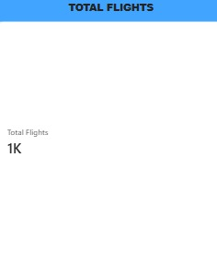

10.2. Unique Routes
The Unique Routes KPI indicates 30 unique source–destination combinations in the dataset. This provides an overview of the range of routes covered by the available flight records.
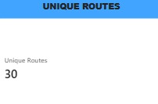
10.3. Valid Flight Percentage
The Valid Flight Percentage is 99.9%, showing that almost all flight records passed the validation checks performed during preprocessing.
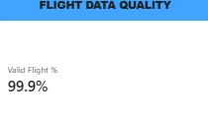
10.4. Average Flight Time
The Average Flight Time is approximately 2.74 hours, representing the average duration of flights in the dataset.
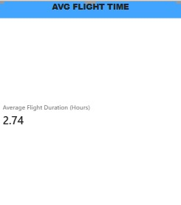
10.5. Flight Anomalies
The dashboard identifies 1 flight anomaly. This corresponds to the flight record where the departure and arrival timestamps were inconsistent with the recorded duration. The record was retained and flagged rather than being removed.
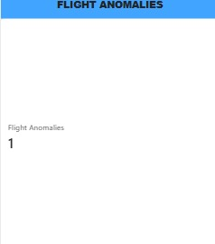
10.6. Average Flight Duration by Airline
The Average Flight Duration by Airline graph compares the average duration of flights operated by different airlines. This helps identify differences in average flight time across airlines and provides a comparison of their operational flight durations.
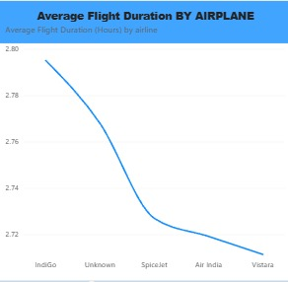
10.7. Flight Quality Distribution
The Flight Quality Distribution visual shows the proportion of flight records classified as valid or anomalous. The visualization demonstrates that the dataset contains approximately 1K valid-quality records, with only a very small number of anomalous records.
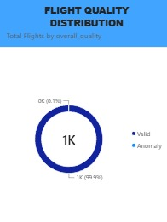
10.8. Flight Volume by Airline
The Flight Volume by Airline pie chart presents the distribution of flights among the airlines in the dataset. It allows the relative contribution of each airline to the overall flight volume to be compared easily.
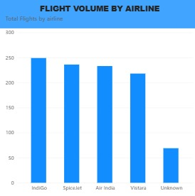
10.9. Flight Volume by Destination
The Flight Volume by Destination bar chart shows the number of flights associated with each destination. It helps identify destinations with higher or lower flight volumes within the dataset.
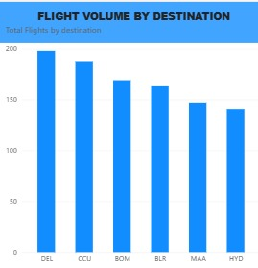
Overall, the dashboard provides a compact view of the scale, route coverage, operational duration and data quality of the airline dataset. The high valid-flight percentage and the presence of only one identified anomaly indicate that the flight data was largely consistent after preprocessing. The airline and destination visualizations also provide a straightforward way to compare flight distribution across different categories.

